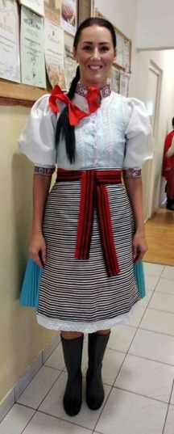  professional summary  I studied two separate master's courses of biology and chemistry teaching and environmental ecology at Faculty of Natural Sciences, University of P. J. Safarik in Kosice. In 2007 I was awarded the title of Doctor of Natural Sciences. I have been teaching for eleven years, and my profession is a hobby for me and a heart matter. I work as a high school biology and chemistry teacher with both attestations. I have been fulfilling my childhood teaching dream at Grammar School in Gelnica. I started my teaching career as an educator and I taught at a school with a majority group of Roma pupils. In the course of vocational training, I have completed numerous training courses. Every day I implement the acquired knowledge, skills and competences in the teaching of my pupils - my “school” children.  skills  - Language: English / Level B1, German / Level B1  - Computer: Microsoft Windows, Microsoft Office Standard (Word, Excel, PowerPoint) – common user, Internet – common user | Lenka šKARBEKOVÁ  Country: slovakia | nationality: slovak  date of birth: 29/06/1984  education  2007-2009  Title of qualification obtained: general education teachers  Main subjects/occupational skills: biology – chemistry  Title and type of organization providing education and training: Faculty of Natural Sciences, University of P. J. Safarik in Kosice, university  Degree in national or international classification: higher education degree (Mgr.)  2007  Title of qualification: doctor of natural sciences  Main subjects/occupational skills: biology  Title and type of education and training organization: Faculty of Science, University of P. J. Safarik in Kosice, university  Degree of education in national or international classification: rigorous study (RNDr.  2002-2007  Title of qualification: one-field master's degree  Main subjects/occupational skills: Environmental ecology  Name and type of education and training organization: Faculty of Natural Sciences, University of P. J. Safarik in Kosice, university  Degree of education in national or international classification: higher education degree (Mgr.)  work experience  2008-2010  From – To: August 2011 – duration  Employment or occupation: High school teacher  Main activities and responsibilities: Class teacher, Environmental  education coordinator  Name and address of the employer: Grammar School - Gymnázium  SNP 1, 056 01 Gelnica  Type of work or sector of education: secondary general education  2008-2010  Employment or occupation: educator  Main activities and responsibilities: coordinator of environmental  activities  Name and address of employer: Leisure Center Gelnica, Slovenská  46, 056 01 Gelnica  Type of work or sector of education: leisure centre for children  and youth  2010-2011  Employment or occupation: teacher  Main activities and responsibilities: class teacher, environmental  education coordinator  Name and address of the employer: Základná škola Švedlár, Školská  121, 053 34 Švedlár  Type of work or sector of education: elementary education  activities and HOBBIES  I love my job and my family. My hobbies include sports and movement (running, football, swimming, dancing), nature, cooking, hiking and youth work and experiments. I am very sociable and adaptable, I like a cheerful active company of people, where there is a lack of good mood, singing and wit. In 2019, I was part of the TOP 10 best teachers in Slovakia.

